Report – Data harmonization for Italy

**Encoding**

All variables were coded as for HEROES codebook

**Merging**

The Italy data set was merged with table “Region_Mobility_Report” by *time* and *NUTS 2*. It was merged then with the data set with tables “NUTS” by *NUTS 2* and with stringency index by *time.*

**Missing values**

Some **variables are missing for all the original dataset** (e.g. sd08new, sd10, is46b) and **scales specifically** (GAD-7 and pc PTSD).

Some information of **“Region_Mobility_Report”** was missing (e.g. metro_area, census_fips_code, juridiction).

**Results**

You can find below a simple view of **main descriptive results** and **graphs of missing values** using the function vismiss()

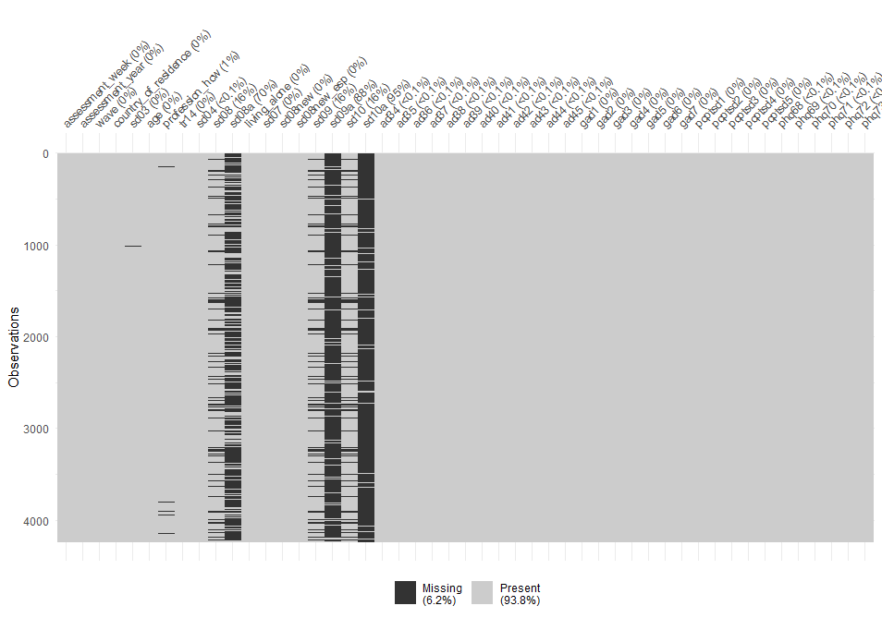

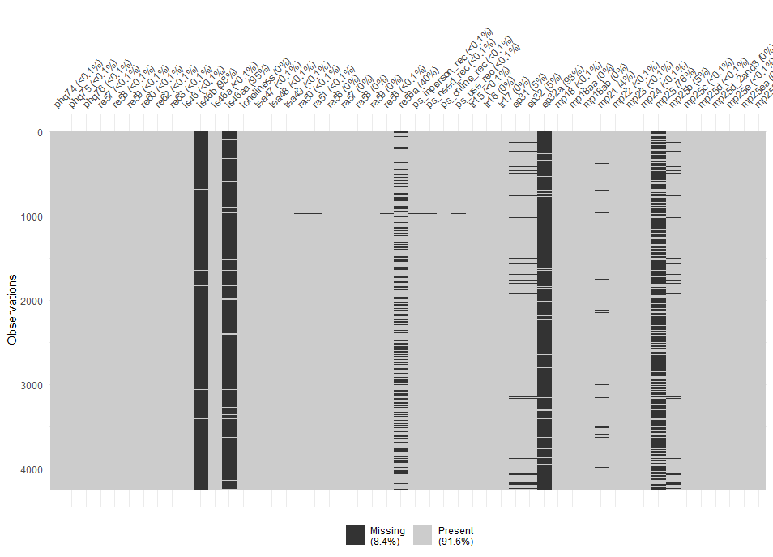

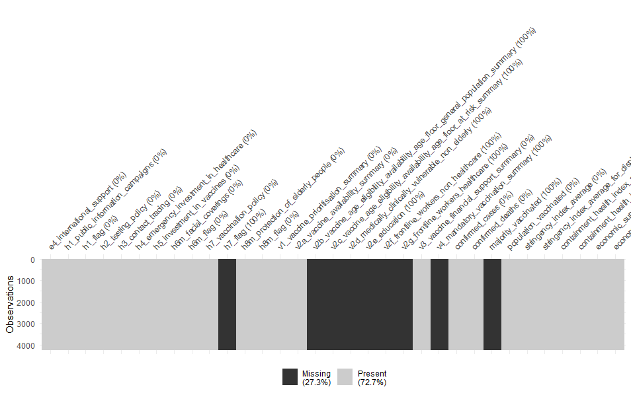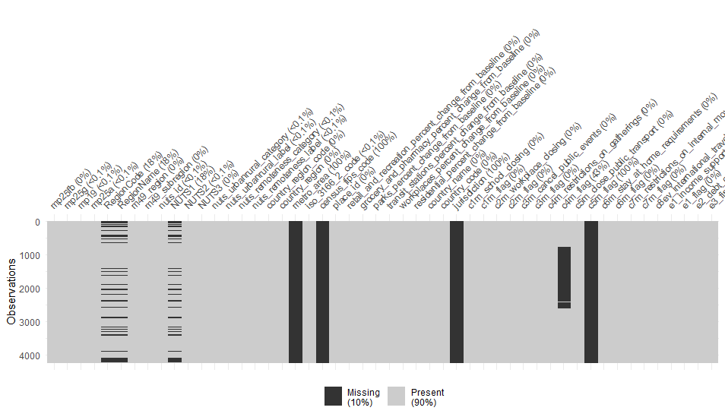

*Table 1 : Distribution of total sample by main variables*

